**Test Summary Report**

**STR**

**Tested and written by Haya Ben abu**

**Table of contents**

1. Purpose………………………………………..3
2. Application Overview…………………………3
3. Metrics……………………………………….4-7
4. Recommendations………………………….…8
5. Conclusions ………………………………...…8
6. Bugs list……………………………………..….9
7. Bugs Report ……………………………...10-26

**Purpose**

The purpose of the following report is to present the set of tests I did on the site by classifying test areas on the site. The tests were performed in all the areas offered to the client, among others: customer service for new entrants, the diverse insurance menu, useful information for the client, the accessibility area for disabled users and the The WhatsApp service which is a convenient alternative for the customer to receive service.

**Application Overview**

I chose to carry out my testing project on the Wobi website. Wobi is actually a digital insurance agency, that offers its customers price comparison options between the various insurances in a variety of areas, such as: car insurance, apartment, mortgage and even travel abroad.

The site works in cooperation with the insurance companies in Israel, and is actually an intermediary between the insured and the insurance companies.

The service that the company provides to its customers is through a website, establishing telephone contact with insurance personnel, and even through a digital representative on WhatsApp.

**Metrics**

**Test Areas**

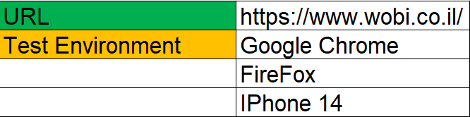

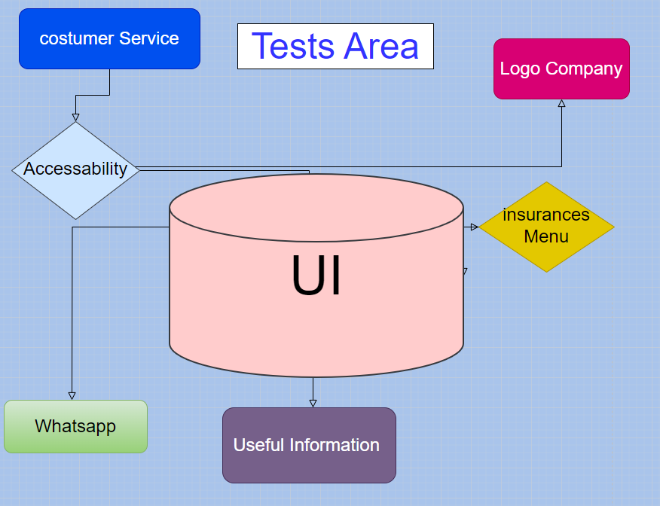

**Tests Cases**

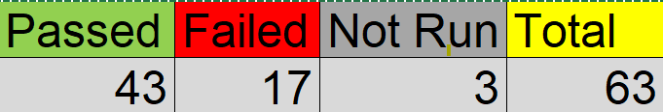

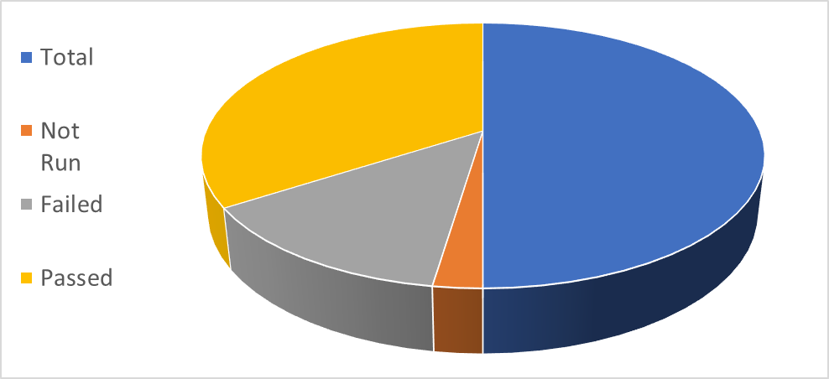

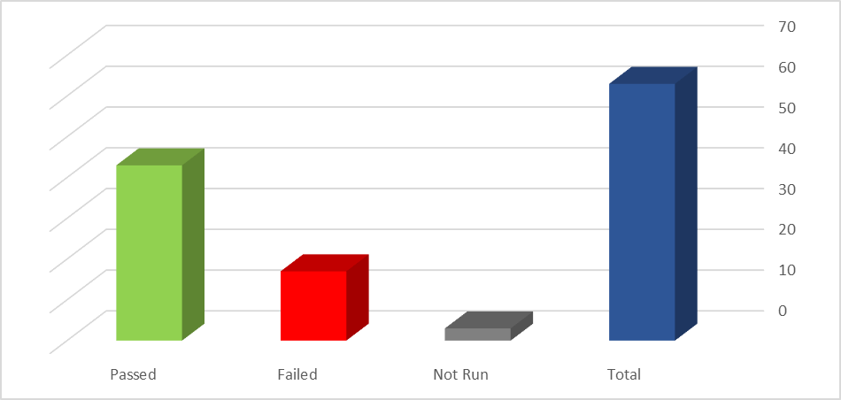

**Severity of Bugs**

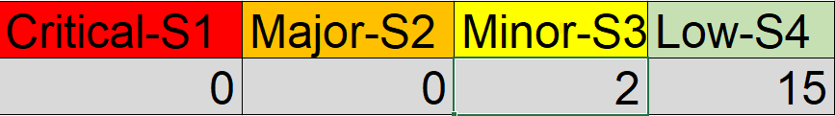

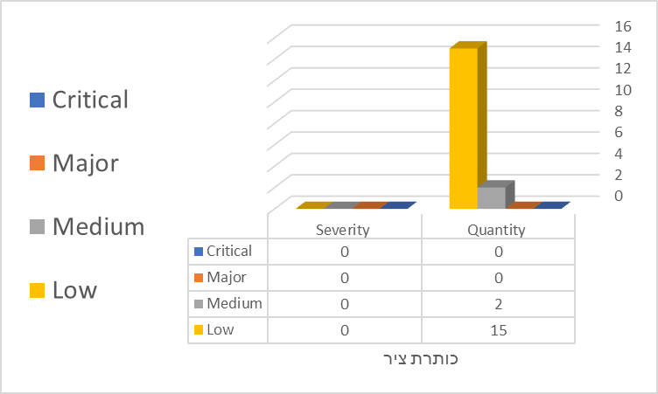

**Types of Tests**

|  |  |  |  |  |
| --- | --- | --- | --- | --- |
| S5-Law | S4-Medium | S3-  Major | S2- Critical |  |
| 2 | 2 | 0 | 0 | Functional |
| 5 | 0 | 0 | 0 | Usability |
| 1 | 0 | 0 | 0 | Interface Tests |
| 1 | 0 | 0 | 0 | Compatibility |
| 4 | 0 | 0 | 0 | GUI |
| 2 | 0 | 0 | 0 | Accessibility |

**Recommendations**

1. Lack of speech and verbal content for the client- after reviewing the site I came up with a lot of questions that came up and I had to come up with the answers myself.
2. Remove links from rubrics that do not constitute an actual link. Causing a poor user experience.
3. In the "new entrants" rubric it is not possible to join digitally. The site actually offers the customer the option to join by leaving contact information and waiting for a service representative to return. Which can miss the opportunity to add the customer.

**conclusion**

After completing the review of the site and examining the bugs found, it seems that over all the site is functioning properly and the bugs that were found were more aimed at the visibility of the site and the user experience. Therefore, I would like to recommend the release of the site to the target audience.

**List of Bugs**

1. [In the Firefox browser, the site's phone link "allowed" me to dial, but it is not possible to dial through a website](https://hayamishal-1688797600572.atlassian.net/browse/WOBI305-6)
2. [A phone number appears for the site that appears as a link, but clicking on it does not allow me to dial](https://hayamishal-1688797600572.atlassian.net/browse/WOBI305-4)
3. Under the rubric "new entrants" there is no option for travel insurance abroad
4. [In "Download forms" for claims, there is an option to download instructions for filling out forms instead of downloading the forms themselves](https://hayamishal.atlassian.net/browse/WOB305-1)
5. [Some of the icons of the insurance companies do not appear](https://hayamishal.atlassian.net/browse/WOB305-2)
6. [I entered the year 2025 in the date of birth and the date of issuance of the ID card and the website did not warn of an error](https://hayamishal-1688797600572.atlassian.net/browse/WOBI305-3)
7. [In "Health and Life Insurance" a small square appears in the background which appears to be a bug](https://hayamishal-1688797600572.atlassian.net/browse/WOBI305-13)
8. [When I clicked underline in accessibility the "new joiners" button was not underlined.](https://hayamishal-1688797600572.atlassian.net/browse/WOBI305-14)
9. [A legible font in "Accessibility" enlarges the text just a little bit](https://hayamishal-1688797600572.atlassian.net/browse/WOBI305-15)
10. [There is no mortgage insurance in the WhatsApp service](https://hayamishal.atlassian.net/browse/WOB305-3)
11. At the bottom of the site under "Contact" there is a YouTube icon. It is not relevant to contact.
12. [On the site map under one of the rubrics there is another "call now" link that does not allow me to actually dial](https://hayamishal-1688797600572.atlassian.net/browse/WOBI305-7)
13. [On the site map there is a rubric of "Sport 5 thank you"](https://hayamishal-1688797600572.atlassian.net/browse/WOBI305-8)
14. [The site map offers an option to contact and leave details when this is not possible in practice](https://hayamishal-1688797600572.atlassian.net/browse/WOBI305-9)
15. [In "all articles" below there is a link to LinkedIn that is not accessible.](https://hayamishal-1688797600572.atlassian.net/browse/WOBI305-11)
16. [In the "terms of use" there is a link to a phone number where you can remove advertising mail from the customer. The link does not allow actual dialing.](https://hayamishal-1688797600572.atlassian.net/browse/WOBI305-10)
17. [In "all articles" the "loans" icon is missing and the "pension" icon is split](https://hayamishal-1688797600572.atlassian.net/browse/WOBI305-12).

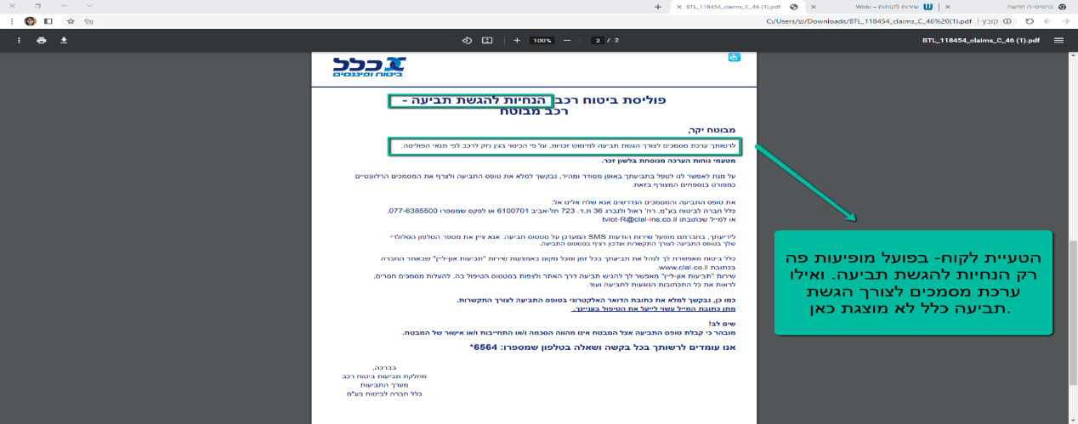

|  |  |  |  |  |  |
| --- | --- | --- | --- | --- | --- |
| [WOB305-1]  [In "Download forms" for claims, there is an option to download instructions for filling out forms instead of downloading the forms themselves](https://hayamishal.atlassian.net/browse/WOB305-1) Created: 14/Jul/23  Updated: 14/Jul/23 | | | | | |
| **Status:** | | | To Do | | |
| **Project:** | | | [WOBI305](https://hayamishal.atlassian.net/secure/BrowseProject.jspa?id=10001) | | |
| **Components:** | | | None | | |
| **Affects versions:** | | | None | | |
| **Fix versions:** | | | None | | |
| **Severity:** | | | Medium | | |
| **Type:** | | Bug | | **Priority:** | Medium |
| **Reporter:** | | [Haya Ben abu](https://hayamishal.atlassian.net/secure/ViewProfile.jspa?accountId=712020%3Aeb595526-f7a4-48bb-bc68-7881d6a5f67b) | | **Assignee:** | Unassigned |
| **Resolution:** | | Unresolved | | **Votes:** | 0 |
| **Environment:** | | Chrome browser | | | |
| **Severity:** | | | Medium | | |  |
| **Description** |  | | | | | |

|  |  |  |  |  |  |
| --- | --- | --- | --- | --- | --- |
| **steps to reproduce:**   1. open URL <https://www.wobi.co.il/> 2. Click on Customer Service 3. Download forms>Filter>Car insurance>Claim> "Clal" 4. Instructions for submitting a claim > click "Download" 5. Click on the page that opens at the bottom of the screen   **actual result:**  A page opens with instructions for filing a claim with the "Clal" And it is noted that a set of documents for the lawsuit is attached, but the set of documents is missing  **expected result:**  Attach the forms required to fill out the claim | | | | | |
| [WOB305-2]  [Some of the icons of the insurance companies do not appear](https://hayamishal.atlassian.net/browse/WOB305-2) Created: 14/Jul/23  Updated: 14/Jul/23 | | | | | |
| **Status:** | | | To Do | | |
| **Project:** | | | [WOBI305](https://hayamishal.atlassian.net/secure/BrowseProject.jspa?id=10001) | | |
| **Components:** | | | None | | |
| **Affects versions:** | | | None | | |
| **Fix versions:** | | | None | | |
| **Severity:** | | | Low | | |
| **Type:** | | Bug | | **Priority:** | Medium |
| **Reporter:** | | [Haya Ben abu](https://hayamishal.atlassian.net/secure/ViewProfile.jspa?accountId=712020%3Aeb595526-f7a4-48bb-bc68-7881d6a5f67b) | | **Assignee:** | Unassigned |
| **Resolution:** | | Unresolved | | **Votes:** | 0 |
| **Environment:** | | Chrome browser | | | |
| **Severity:** | | | Low | | |  |
| **Description** |  | | | | | |

|  |
| --- |
| **steps to reproduce:**   1. open URL <https://www.wobi.co.il/> 2. Click on "travel insurance abroad"   **actual result:**  Two icons of insurance companies to the right of "Harel" do not appear  **expected result:**  The icons of all insurance companies will appear |

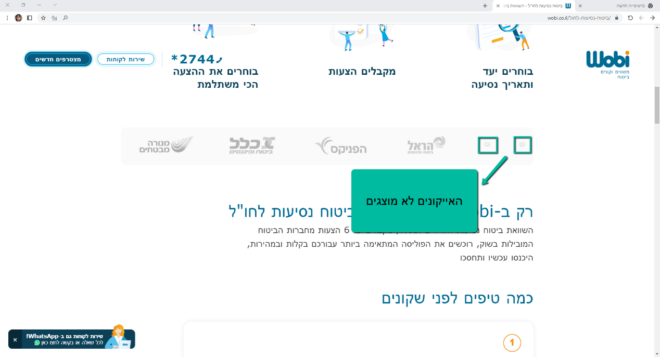

|  |  |  |  |  |
| --- | --- | --- | --- | --- |
| [WOBI305-3] [I entered the year 2025 in the date of birth and the date of issuance of the ID card and the website did not warn of an error](https://hayamishal-1688797600572.atlassian.net/browse/WOBI305-3) Created: 14/Jul/23  Updated: 14/Jul/23 | | | | |
| **Status:** | | To Do | | |
| **Project:** | | [WOBI](https://hayamishal-1688797600572.atlassian.net/secure/BrowseProject.jspa?id=10002) | | |
| **Components:** | | None | | |
| **Affects versions:** | | None | | |
| **Fix versions:** | | None | | |
| **Type:** | Bug | | **Priority:** | Medium |
| **Reporter:** | [Haya Ben abu](https://hayamishal.atlassian.net/secure/ViewProfile.jspa?accountId=712020%3Aeb595526-f7a4-48bb-bc68-7881d6a5f67b) | | **Assignee:** | Unassigned |
| **Resolution:** | Unresolved | | **Votes:** | 0 |
| **Environment:** | Chrome browser | | | |
| **Severity:** | | Medium | | |

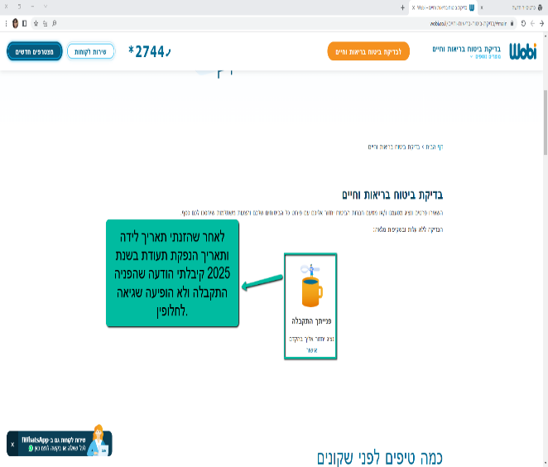

|  |  |
| --- | --- |
| **Description** |  |

|  |
| --- |
| **steps to reproduce:**   1. open URL <https://www.wobi.co.il/> 2. Click on “health and life insurance check” 3. Enter personal details and future year of birth in the rubrics of date of birth and date of issuance of ID card 4. Click on "Call me"   **actual result:**  The site did not recognize this as an error and informed me that my details were successfully received  **expected result:**  The site will identify the future year as an error and will not progress until I write a "correct" year |

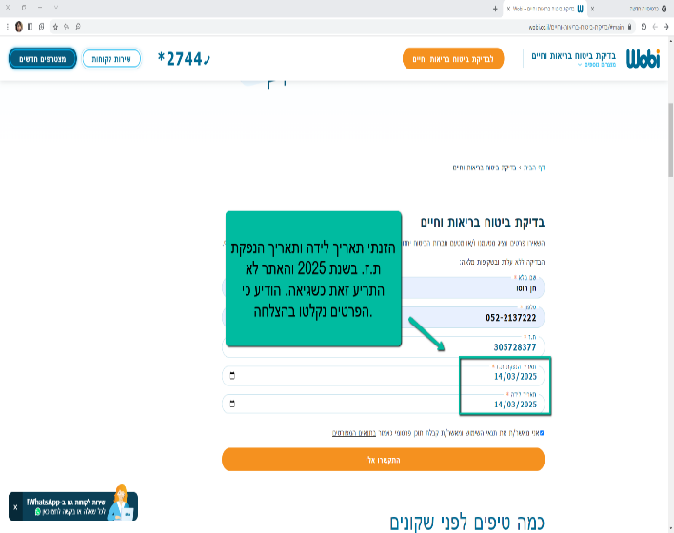

|  |  |  |  |  |  |
| --- | --- | --- | --- | --- | --- |
| [WOBI305-4] [A phone number appears for the site that appears as a link, but clicking on it does not allow me to dial](https://hayamishal-1688797600572.atlassian.net/browse/WOBI305-4) Created: 14/Jul/23  Updated: 14/Jul/23 | | | | | |
| **Status:** | | To Do | | | |
| **Project:** | | [WOBI](https://hayamishal-1688797600572.atlassian.net/secure/BrowseProject.jspa?id=10002) | | | |
| **Components:** | | None | | | |
| **Affects versions:** | | None | | | |
| **Fix versions:** | | None | | | |
| **Type:** | Bug | | **Priority:** | Medium |
| **Reporter:** | [Haya Ben abu](https://hayamishal.atlassian.net/secure/ViewProfile.jspa?accountId=712020%3Aeb595526-f7a4-48bb-bc68-7881d6a5f67b) | | **Assignee:** | Unassigned |
| **Resolution:** | Unresolved | | **Votes:** | 0 |
| **Environment:** | Chrome browser | | | |
| **Severity:** | | Low | | | |

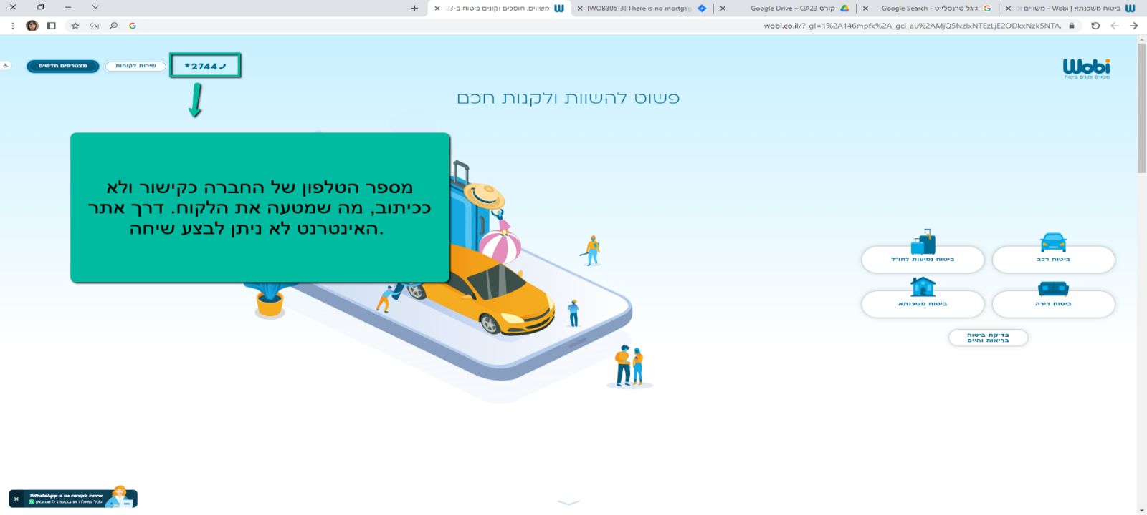

|  |  |
| --- | --- |
| **Description** |  |

|  |  |  |  |  |  |
| --- | --- | --- | --- | --- | --- |
| **steps to reproduce:**   1. open URL <https://www.wobi.co.il/> 2. Click on the phone number   **actual result:**  Clicking on the phone number link on the website did not allow me to dial  **expected result:**  The phone number on the site should appear as a caption and not as a link | | | | | |
| [WOBI305-5]  [At the bottom of the site under "Contact" there is a YouTube icon. It is not relevant to contact.](https://hayamishal-1688797600572.atlassian.net/browse/WOBI305-5) Created: 14/Jul/23  Updated: 14/Jul/23 | | | | | |
| **Status:** | | To Do | | | |
| **Project:** | | [WOBI](https://hayamishal-1688797600572.atlassian.net/secure/BrowseProject.jspa?id=10002) | | | |
| **Components:** | | None | | | |
| **Affects versions:** | | None | | | |
| **Fix versions:** | | None | | | |
| **Type:** | Bug | | **Priority:** | Medium |
| **Reporter:** | [Haya Ben abu](https://hayamishal.atlassian.net/secure/ViewProfile.jspa?accountId=712020%3Aeb595526-f7a4-48bb-bc68-7881d6a5f67b) | | **Assignee:** | Unassigned |
| **Resolution:** | Unresolved | | **Votes:** | 0 |
| **Environment:** | Chrome browser | | | |
| **Severity:** | | Low | | | |

|  |  |
| --- | --- |
| **Description** |  |

|  |
| --- |
| **steps to reproduce:**   1. open URL <https://www.wobi.co.il/> 2. Go to the bottom of the page 3. Click on the YouTube icon   **actual result:**  I see an Promotional video on the site and no contact option  **expected result:**  Only the relevant icons for contact will appear |

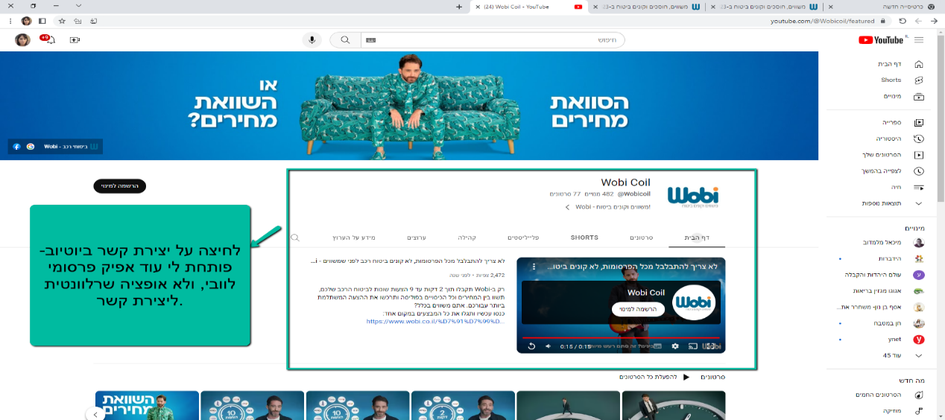

|  |  |  |  |  |  |
| --- | --- | --- | --- | --- | --- |
| [WOBI305-6] [In the Firefox browser, the site's phone link "allowed" me to dial, but it is not possible to dial through a website](https://hayamishal-1688797600572.atlassian.net/browse/WOBI305-6) Created: 14/Jul/23  Updated: 14/Jul/23 | | | | | |
| **Status:** | | To Do | | | |
| **Project:** | | [WOBI](https://hayamishal-1688797600572.atlassian.net/secure/BrowseProject.jspa?id=10002) | | | |
| **Components:** | | None | | | |
| **Affects versions:** | | None | | | |
| **Fix versions:** | | None | | | |
| **Type:** | Bug | | **Priority:** | Medium |
| **Reporter:** | [Haya Ben abu](https://hayamishal.atlassian.net/secure/ViewProfile.jspa?accountId=712020%3Aeb595526-f7a4-48bb-bc68-7881d6a5f67b) | | **Assignee:** | Unassigned |
| **Resolution:** | Unresolved | | **Votes:** | 0 |
| **Environment:** | Chrome browser | | | |
| **Severity:** | | Low | | | |

|  |  |
| --- | --- |
| **Description** |  |

|  |
| --- |
| **steps to reproduce:**   1. Log in to the Firefox browser 2. open URL <https://www.wobi.co.il/> 3. Click on the website phone number link 4. A small window will open, offering me to dial using a certain application that I choose   **actual result:**  I did not "succeed" in dialing because there is no option to dial through a website  **expected result:**  Display the phone number as a caption and not as a link |

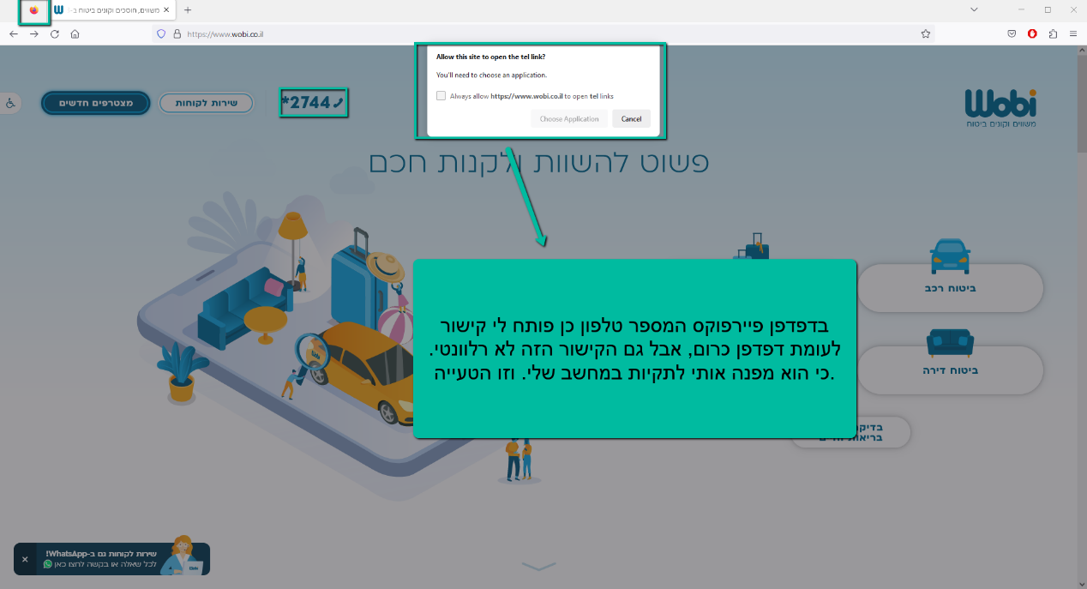

|  |  |  |  |  |  |
| --- | --- | --- | --- | --- | --- |
| [WOBI305-7] [On the site map under one of the rubrics there is another "call now" link that does not allow me to actually dial](https://hayamishal-1688797600572.atlassian.net/browse/WOBI305-7) Created: 14/Jul/23  Updated: 14/Jul/23 | | | | | |
| **Status:** | | To Do | | | |
| **Project:** | | [WOBI](https://hayamishal-1688797600572.atlassian.net/secure/BrowseProject.jspa?id=10002) | | | |
| **Components:** | | None | | | |
| **Affects versions:** | | None | | | |
| **Fix versions:** | | None | | | |
| **Type:** | Bug | | **Priority:** | Medium |
| **Reporter:** | [Haya Ben abu](https://hayamishal.atlassian.net/secure/ViewProfile.jspa?accountId=712020%3Aeb595526-f7a4-48bb-bc68-7881d6a5f67b) | | **Assignee:** | Unassigned |
| **Resolution:** | Unresolved | | **Votes:** | 0 |
| **Environment:** | Chrome browser | | | |
| **Severity:** | | Low | | | |

|  |  |
| --- | --- |
| **Description** |  |

|  |
| --- |
| **steps to reproduce:**   1. open URL <https://www.wobi.co.il/> 2. Go to the bottom of the page 3. Click on "site map" 4. Click on the rubric "9 suggestions? It's a safe insurance" 5. Go down to the bottom of the page again 6. Click on the "Call Now" link   **actual result:**  The link did not allow me to make a call  **expected result:**  The phone number of the site without a link will appear instead |

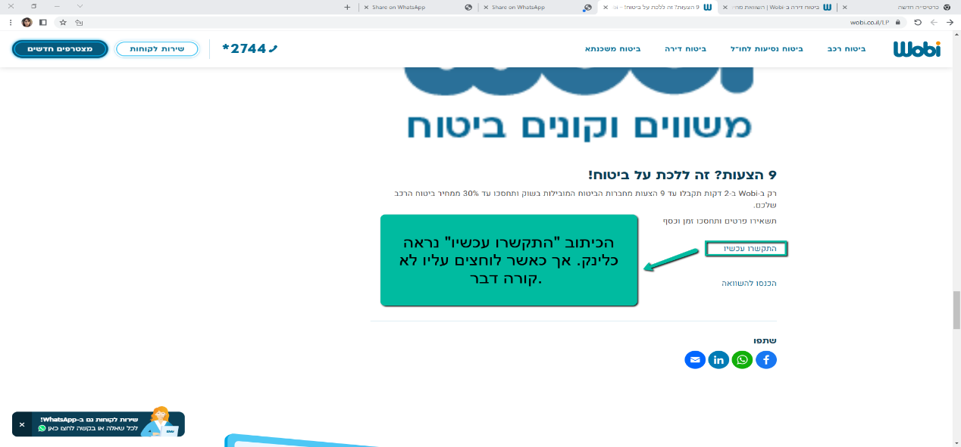

|  |  |  |  |  |  |
| --- | --- | --- | --- | --- | --- |
| [WOBI305-8] [On the site map there is a rubric of "Sport 5 thank you"](https://hayamishal-1688797600572.atlassian.net/browse/WOBI305-8) Created: 14/Jul/23  Updated: 14/Jul/23 | | | | | |
| **Status:** | | To Do | | | |
| **Project:** | | [WOBI](https://hayamishal-1688797600572.atlassian.net/secure/BrowseProject.jspa?id=10002) | | | |
| **Components:** | | None | | | |
| **Affects versions:** | | None | | | |
| **Fix versions:** | | None | | | |
| **Type:** | Bug | | **Priority:** | Medium |
| **Reporter:** | [Haya Ben abu](https://hayamishal.atlassian.net/secure/ViewProfile.jspa?accountId=712020%3Aeb595526-f7a4-48bb-bc68-7881d6a5f67b) | | **Assignee:** | Unassigned |
| **Resolution:** | Unresolved | | **Votes:** | 0 |
| **Environment:** | Chrome browser | | | |
| **Severity:** | | Low | | | |

|  |  |
| --- | --- |
| **Description** |  |

|  |
| --- |
| **steps to reproduce:**   1. open URL <https://www.wobi.co.il/> 2. Go to the bottom of the page 3. Click on "site map" 4. Click on the rubric "Sport5 thank you"   **actual result:**  On the page that opens it says "Sport 5 Thank you" - how is it relevant to an insurance website.  **expected result:**  If this content is indeed relevant to the site, we will indicate the context with some sort of summary |

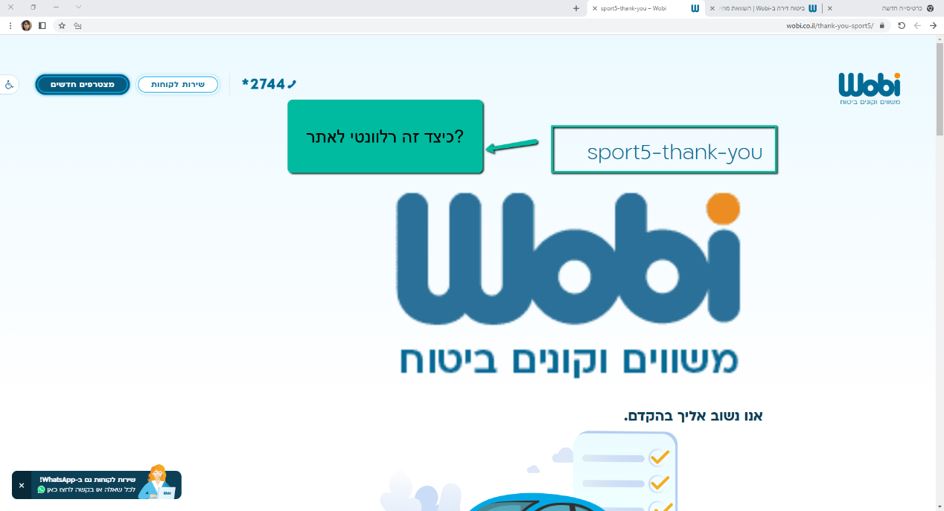

|  |  |  |  |  |  |
| --- | --- | --- | --- | --- | --- |
| [WOBI305-9] [The site map offers an option to contact and leave details when this is not possible in practice](https://hayamishal-1688797600572.atlassian.net/browse/WOBI305-9) Created: 14/Jul/23  Updated: 14/Jul/23 | | | | | |
| **Status:** | | To Do | | | |
| **Project:** | | [WOBI](https://hayamishal-1688797600572.atlassian.net/secure/BrowseProject.jspa?id=10002) | | | |
| **Components:** | | None | | | |
| **Affects versions:** | | None | | | |
| **Fix versions:** | | None | | | |
| **Type:** | Bug | | **Priority:** | Medium |
| **Reporter:** | [Haya Ben abu](https://hayamishal.atlassian.net/secure/ViewProfile.jspa?accountId=712020%3Aeb595526-f7a4-48bb-bc68-7881d6a5f67b) | | **Assignee:** | Unassigned |
| **Resolution:** | Unresolved | | **Votes:** | 0 |
| **Environment:** | Chrome browser | | | |
| **Severity:** | | Low | | | |

|  |  |
| --- | --- |
| **Description** |  |

|  |
| --- |
| **steps to reproduce:**   1. open URL <https://www.wobi.co.il/> 2. Go to the bottom of the page 3. Click on "site map" 4. Click on the rubric "9 suggestions? Full width version"   **actual result:**  at the top the inscription "Leave details and a representative will get back to you as soon as possible:" with no option to leave details.  At the bottom I see a "call now" link, when you click on the link you can't actually call  **expected result:**  Since this is the site map, it is appropriate that they create a link that leads them to a place on the site where they can leave details and/or contact |

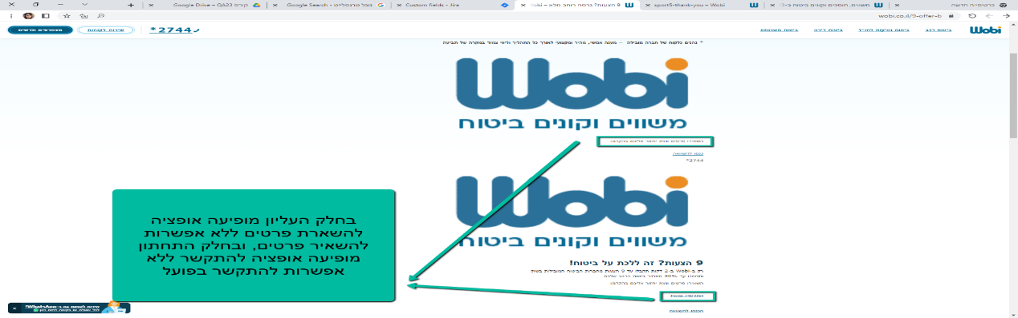

|  |  |  |  |  |  |
| --- | --- | --- | --- | --- | --- |
| [WOBI305-10] [In the "terms of use" there is a link to a phone number where you can remove advertising mail from the customer. The link does not allow actual dialing.](https://hayamishal-1688797600572.atlassian.net/browse/WOBI305-10) Created: 14/Jul/23  Updated: 14/Jul/23 | | | | | |
| **Status:** | | To Do | | | |
| **Project:** | | [WOBI](https://hayamishal-1688797600572.atlassian.net/secure/BrowseProject.jspa?id=10002) | | | |
| **Components:** | | None | | | |
| **Affects versions:** | | None | | | |
| **Fix versions:** | | None | | | |
| **Type:** | Bug | | **Priority:** | Medium |
| **Reporter:** | [Haya Ben abu](https://hayamishal.atlassian.net/secure/ViewProfile.jspa?accountId=712020%3Aeb595526-f7a4-48bb-bc68-7881d6a5f67b) | | **Assignee:** | Unassigned |
| **Resolution:** | Unresolved | | **Votes:** | 0 |
| **Environment:** | Chrome browser | | | |
| **Severity:** | | Low | | | |

|  |  |
| --- | --- |
| **Description** |  |

|  |
| --- |
| **steps to reproduce:**   1. open URL <https://www.wobi.co.il/> 2. Go to the bottom of the page 3. Click on "Terms of Use" 4. Locate the paragraph "Direct Mail and Advertising Matters" 5. Click on the phone number that appears under a link   **actual result:**  Clicking on a link to the phone number does not allow dialing both on the website and on mobile  **expected result:**   1. On the website the phone number will appear as a normal inscription. 2. {{ on a mobile phone it will allow dialing}} |

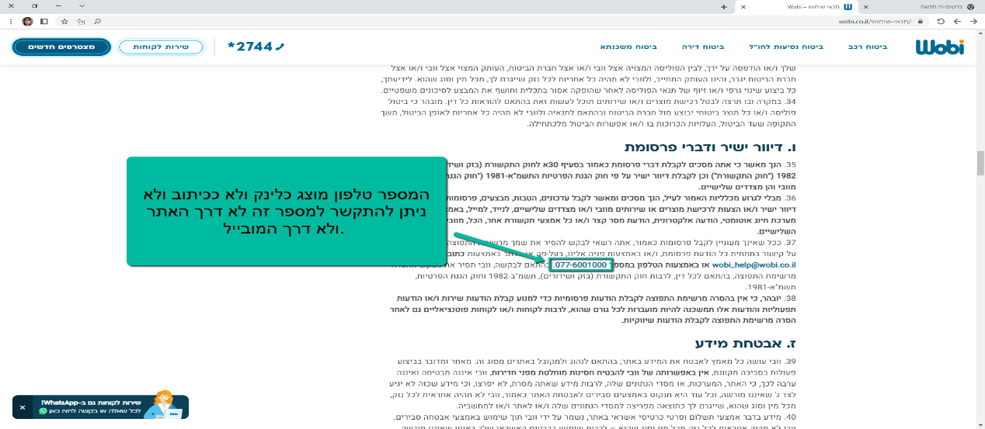

|  |  |  |  |  |  |
| --- | --- | --- | --- | --- | --- |
| [WOBI305-11]  [In "all articles" below there is a link to LinkedIn that is not accessible.](https://hayamishal-1688797600572.atlassian.net/browse/WOBI305-11) Created: 14/Jul/23  Updated: 14/Jul/23 | | | | | |
| **Status:** | | To Do | | | |
| **Project:** | | [WOBI](https://hayamishal-1688797600572.atlassian.net/secure/BrowseProject.jspa?id=10002) | | | |
| **Components:** | | None | | | |
| **Affects versions:** | | None | | | |
| **Fix versions:** | | None | | | |
| **Type:** | Bug | | **Priority:** | Medium |
| **Reporter:** | [Haya Ben abu](https://hayamishal.atlassian.net/secure/ViewProfile.jspa?accountId=712020%3Aeb595526-f7a4-48bb-bc68-7881d6a5f67b) | | **Assignee:** | Unassigned |
| **Resolution:** | Unresolved | | **Votes:** | 0 |
| **Environment:** | Chrome browser | | | |
| **Severity:** | | Low | | | |

|  |  |
| --- | --- |
| **Description** |  |

|  |
| --- |
| **steps to reproduce:**   1. open URL <https://www.wobi.co.il/> 2. Go to the bottom of the page 3. Click on "for all articles" 4. Click on "General Insurance" 5. Click on "Accessibility Statement" (for example) 6. Click on the LinkedIn icon   **actual result:**  No access to LinkedIn  **expected result:**  You will have access to the LinkedIn website |

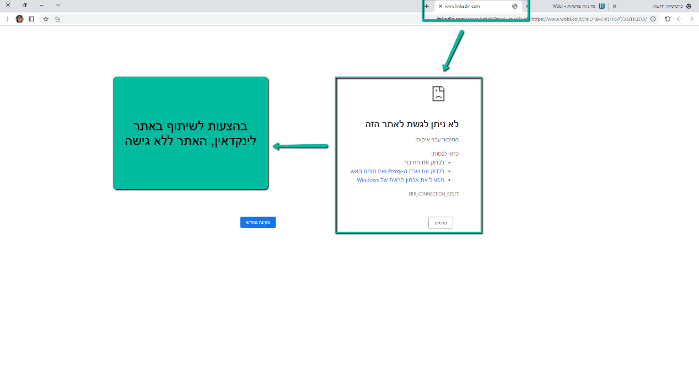

|  |  |  |  |  |  |
| --- | --- | --- | --- | --- | --- |
| [WOBI305-12]  [In "all articles" the "loans" icon is missing and the "pension" icon is split](https://hayamishal-1688797600572.atlassian.net/browse/WOBI305-12) Created: 14/Jul/23  Updated: 14/Jul/23 | | | | | |
| **Status:** | | To Do | | | |
| **Project:** | | [WOBI](https://hayamishal-1688797600572.atlassian.net/secure/BrowseProject.jspa?id=10002) | | | |
| **Components:** | | None | | | |
| **Affects versions:** | | None | | | |
| **Fix versions:** | | None | | | |
| **Type:** | Bug | | **Priority:** | Medium |
| **Reporter:** | [Haya Ben abu](https://hayamishal.atlassian.net/secure/ViewProfile.jspa?accountId=712020%3Aeb595526-f7a4-48bb-bc68-7881d6a5f67b) | | **Assignee:** | Unassigned |
| **Resolution:** | Unresolved | | **Votes:** | 0 |
| **Environment:** | Chrome browser | | | |

|  |  |
| --- | --- |
| **Severity:** | Low |

|  |  |
| --- | --- |
| **Description** |  |

|  |
| --- |
| **steps to reproduce:**   1. open URL <https://www.wobi.co.il/> 2. Go to the bottom of the page 3. Click on "for all articles"   **actual result:**  1.Split "pension" icon  2."Loans" icon is missing  **expected result:**  1. A "pension" icon will have a full icon  2. The "loans" icon will have an icon |

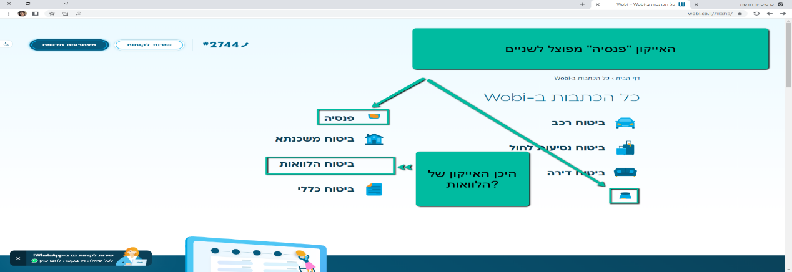

|  |  |  |  |  |  |
| --- | --- | --- | --- | --- | --- |
| [WOBI305-13] [In "Health and Life Insurance" a small square appears in the background which appears to be a bug](https://hayamishal-1688797600572.atlassian.net/browse/WOBI305-13) Created: 14/Jul/23  Updated: 14/Jul/23 | | | | | |
| **Status:** | | To Do | | | |
| **Project:** | | [WOBI](https://hayamishal-1688797600572.atlassian.net/secure/BrowseProject.jspa?id=10002) | | | |
| **Components:** | | None | | | |
| **Affects versions:** | | None | | | |
| **Fix versions:** | | None | | | |
| **Type:** | Bug | | **Priority:** | Medium |
| **Reporter:** | [Haya Ben abu](https://hayamishal.atlassian.net/secure/ViewProfile.jspa?accountId=712020%3Aeb595526-f7a4-48bb-bc68-7881d6a5f67b) | | **Assignee:** | Unassigned |
| **Resolution:** | Unresolved | | **Votes:** | 0 |
| **Environment:** | Chrome browser | | | |
| **Severity:** | | Low | | | |

|  |  |
| --- | --- |
| **Description** |  |

|  |
| --- |
| **steps to reproduce:**   1. open URL <https://www.wobi.co.il/> 2. Click on "Health and Life Insurance"   **actual result:**  Next to the inscription "Insurance doubling" a small square will appear that appears to be a bug  **expected result:**  This irrelevant bug square will be removed |

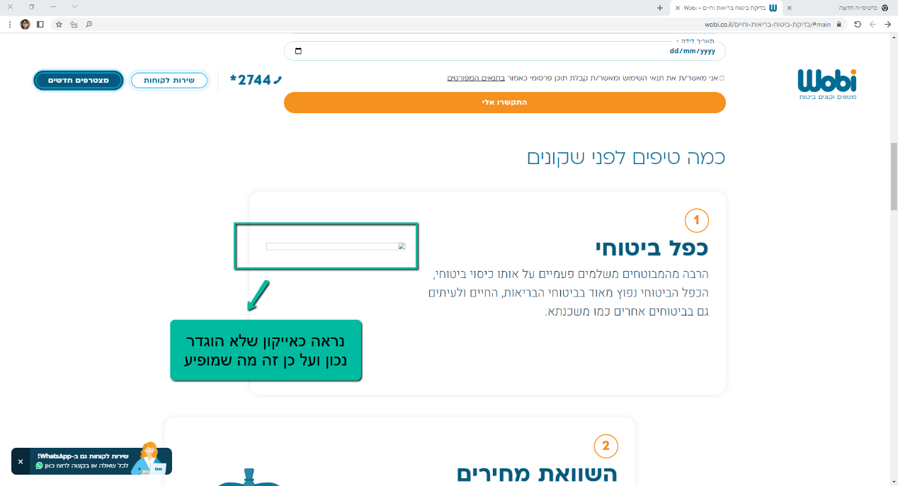

|  |  |  |  |  |  |
| --- | --- | --- | --- | --- | --- |
| [WOBI305-14] [When I clicked underline in accessibility the "new joiners" button was not underlined.](https://hayamishal-1688797600572.atlassian.net/browse/WOBI305-14) Created: 14/Jul/23  Updated: 14/Jul/23 | | | | | |
| **Status:** | | To Do | | | |
| **Project:** | | [WOBI](https://hayamishal-1688797600572.atlassian.net/secure/BrowseProject.jspa?id=10002) | | | |
| **Components:** | | None | | | |
| **Affects versions:** | | None | | | |
| **Fix versions:** | | None | | | |
| **Type:** | Bug | | **Priority:** | Medium |
| **Reporter:** | [Haya Ben abu](https://hayamishal.atlassian.net/secure/ViewProfile.jspa?accountId=712020%3Aeb595526-f7a4-48bb-bc68-7881d6a5f67b) | | **Assignee:** | Unassigned |
| **Resolution:** | Unresolved | | **Votes:** | 0 |
| **Environment:** | Chrome browser | | | |

|  |  |
| --- | --- |
| **Severity:** | Low |

|  |  |
| --- | --- |
| **Description** |  |

|  |
| --- |
| **steps to reproduce:**   1. open URL <https://www.wobi.co.il/> 2. Click on the "Accessibility" button on the left of the site above 3. Click underlined for links   **actual result:**  "New entrants" is not underlined.  **expected result:**  "New entrants" will be underlined in a light color. |

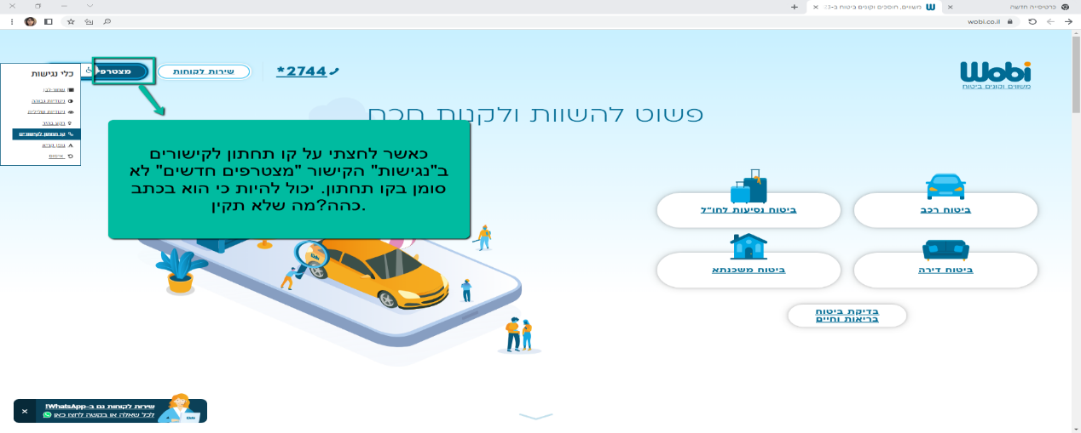

|  |  |  |  |  |  |
| --- | --- | --- | --- | --- | --- |
| [WOBI305-15] [A legible font in "Accessibility" enlarges the text just a little bit](https://hayamishal-1688797600572.atlassian.net/browse/WOBI305-15) Created: 14/Jul/23  Updated: 14/Jul/23 | | | | | |
| **Status:** | | To Do | | | |
| **Project:** | | [WOBI](https://hayamishal-1688797600572.atlassian.net/secure/BrowseProject.jspa?id=10002) | | | |
| **Components:** | | None | | | |
| **Affects versions:** | | None | | | |
| **Fix versions:** | | None | | | |
| **Type:** | Bug | | **Priority:** | Medium |
| **Reporter:** | [Haya Ben abu](https://hayamishal.atlassian.net/secure/ViewProfile.jspa?accountId=712020%3Aeb595526-f7a4-48bb-bc68-7881d6a5f67b) | | **Assignee:** | Unassigned |
| **Resolution:** | Unresolved | | **Votes:** | 0 |
| **Environment:** | Chrome browser | | | |
| **Severity:** | | Low | | | |

|  |  |
| --- | --- |
| **Description** |  |

|  |
| --- |
| **steps to reproduce:**   1. open URL <https://www.wobi.co.il/> 2. Click on the "Accessibility" button on the left side of the website above 3. Click legible font   **actual result:**  The size of the font has been slightly increased  **expected result:**  Since this is accessibility for the visually impaired, the option should be increased to a larger font |

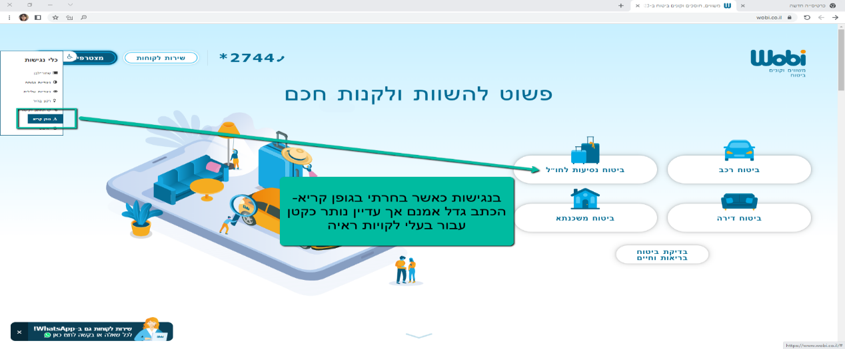

|  |  |  |  |  |  |
| --- | --- | --- | --- | --- | --- |
| [WOBI305-16]  [Under the rubric "new entrants" there is no option for travel insurance abroad](https://hayamishal-1688797600572.atlassian.net/browse/WOBI305-16) Created: 14/Jul/23  Updated: 14/Jul/23 | | | | | |
| **Status:** | | To Do | | | |
| **Project:** | | [WOBI](https://hayamishal-1688797600572.atlassian.net/secure/BrowseProject.jspa?id=10002) | | | |
| **Components:** | | None | | | |
| **Affects versions:** | | None | | | |
| **Fix versions:** | | None | | | |
| **Type:** | Bug | | **Priority:** | Medium |
| **Reporter:** | [Haya Ben abu](https://hayamishal.atlassian.net/secure/ViewProfile.jspa?accountId=712020%3Aeb595526-f7a4-48bb-bc68-7881d6a5f67b) | | **Assignee:** | Unassigned |
| **Resolution:** | Unresolved | | **Votes:** | 0 |
| **Environment:** | Chrome browser | | | |
| **Severity:** | | Low | | | |

|  |  |
| --- | --- |
| **Description** |  |

|  |
| --- |
| **steps to reproduce:**   1. open URL <https://www.wobi.co.il/> 2. Click on "New Members" 3. Click on a topic   **actual result:**  The topic of travel insurance abroad did not appear  **expected result:**  The topic of travel insurance abroad will appear |

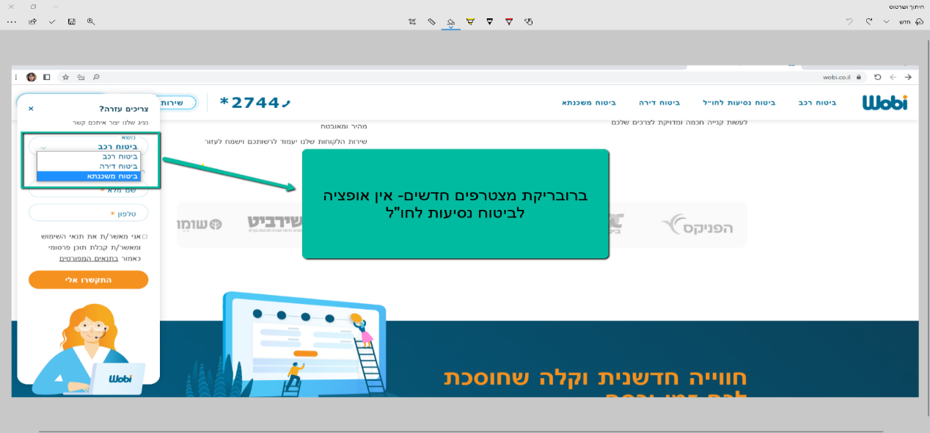

|  |  |
| --- | --- |
| [WOB305-17] [There is no mortgage insurance in the WhatsApp service](https://hayamishal.atlassian.net/browse/WOB305-3) Created: 15/Jul/23  Updated: 15/Jul/23 | |
| **Status:** | To Do |
| **Project:** | [WOBI305](https://hayamishal.atlassian.net/secure/BrowseProject.jspa?id=10001) |
| **Components:** | None |
| **Affects versions:** | None |
| **Fix versions:** | None |

|  |  |  |  |
| --- | --- | --- | --- |
| **Type:** | Bug | **Priority:** | Medium |
| **Reporter:** | [Haya Ben abu](https://hayamishal.atlassian.net/secure/ViewProfile.jspa?accountId=712020%3Aeb595526-f7a4-48bb-bc68-7881d6a5f67b) | **Assignee:** | Unassigned |
| **Resolution:** | Unresolved | **Votes:** | 0 |
| **Environment:** | Chrome browser | | |
| **Severity:** | Low | | |
|  | | | |

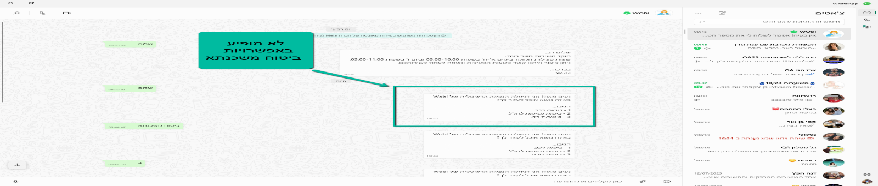

|  |  |
| --- | --- |
| **Description** |  |

|  |
| --- |
| **steps to reproduce:**   1. open URL <https://www.wobi.co.il/> 2. Click on a digital representative on WhatsApp at the bottom of the website 3. Write some kind of opening word to start the conversation with the representative 4. An automatic response will be sent to you by the "representative", in which there are three options for choosing the requested insurance subject   **actual result:**  Appeared in the selection menu for home insurance, foreign travel and car insurance. No mortgage insurance offer  **expected result:**  An option to receive service for mortgage insurance will appear in the menu |